TP 3 Java EE Plante

Servlet JSP JSTL MVC JDBC MYSQL

1)

2)

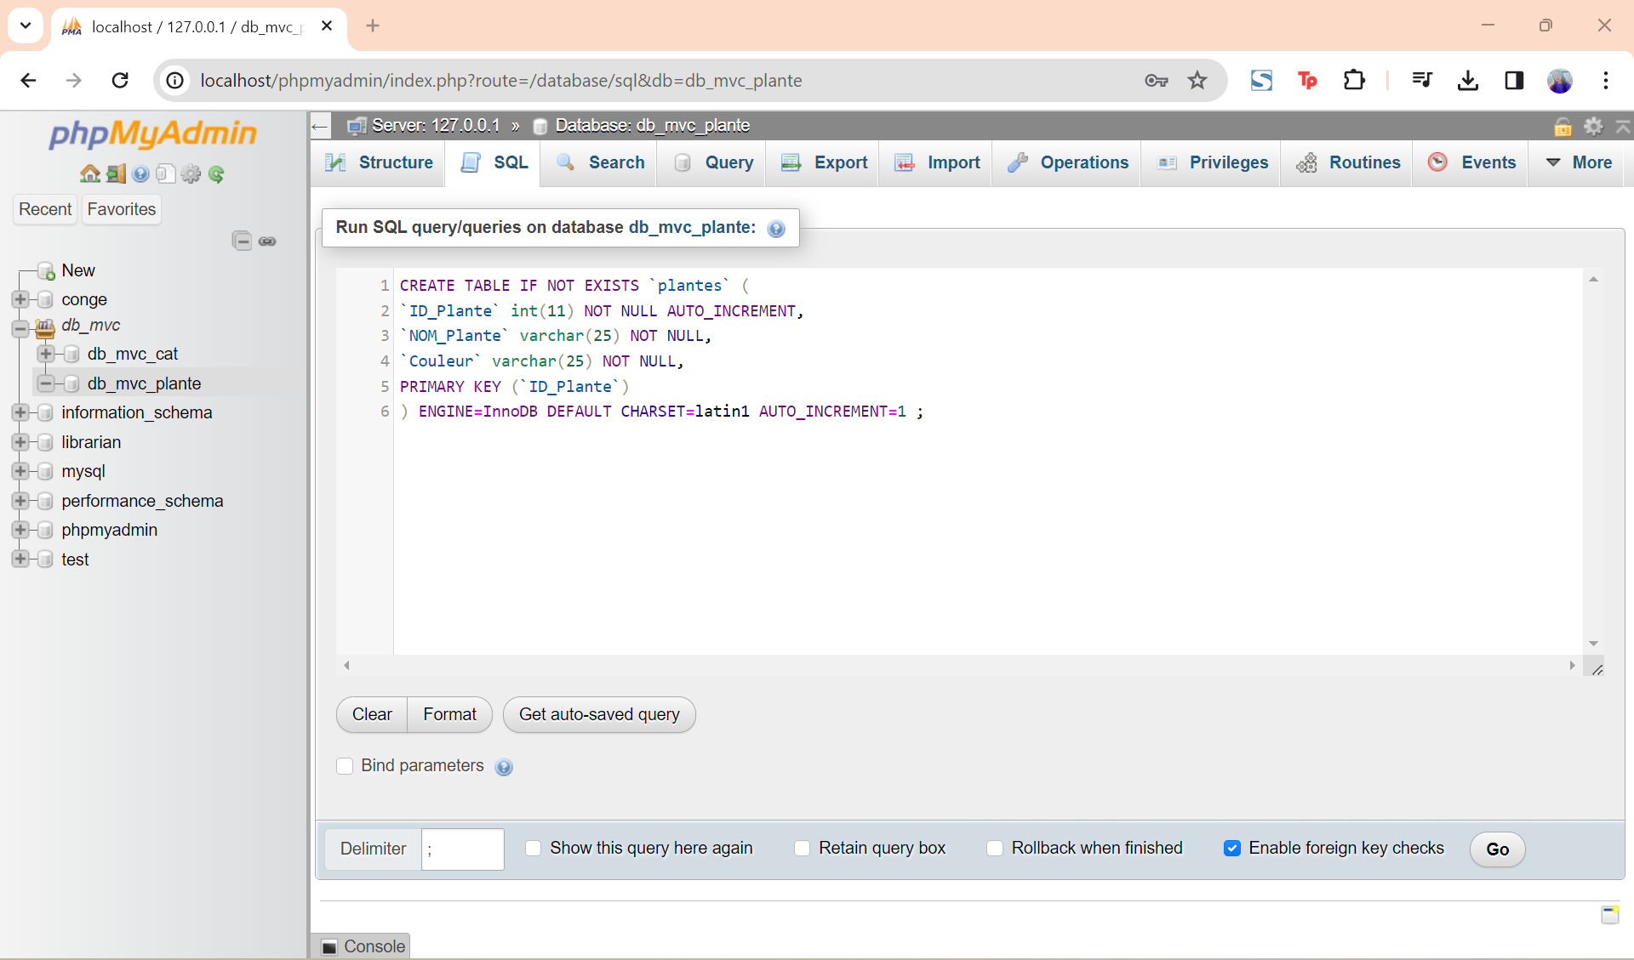

3)

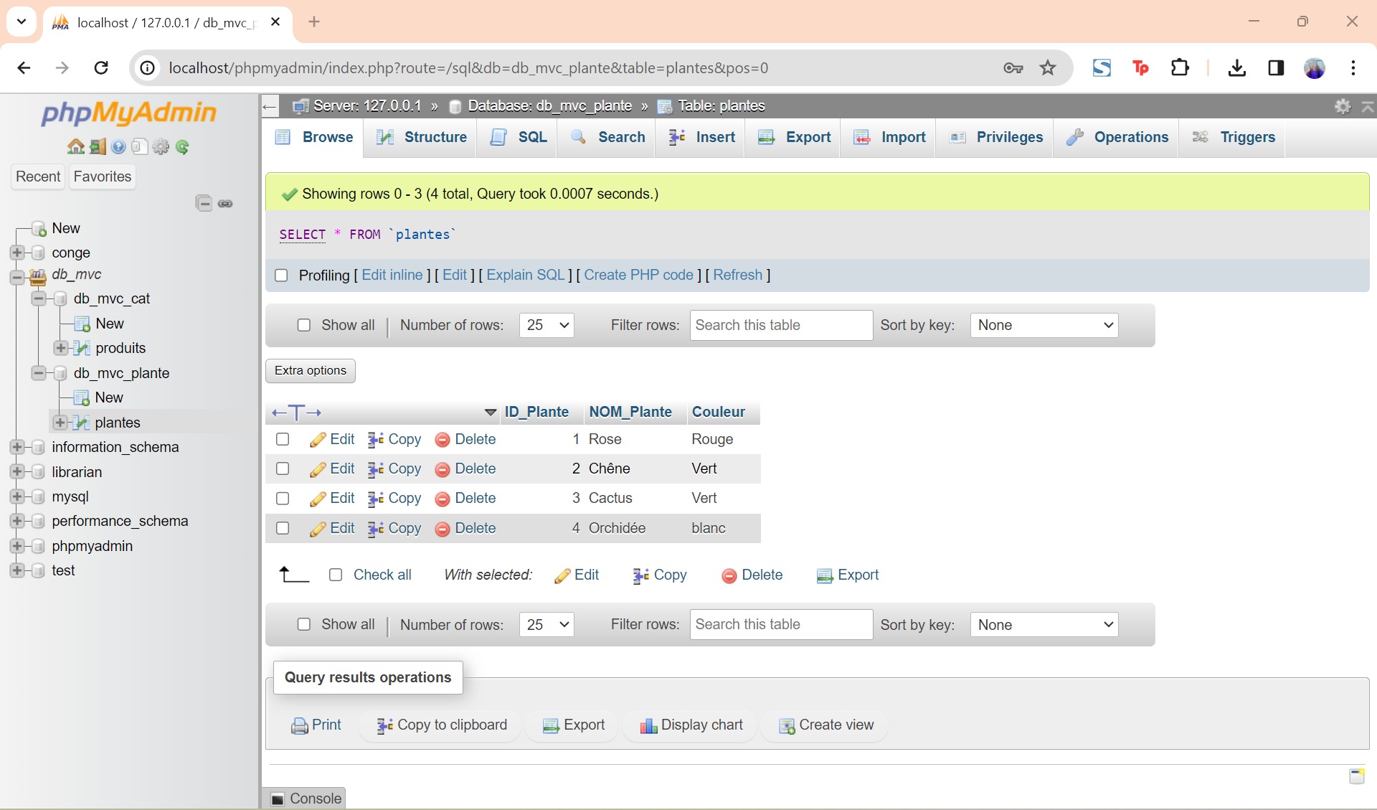

4)

5)

6)

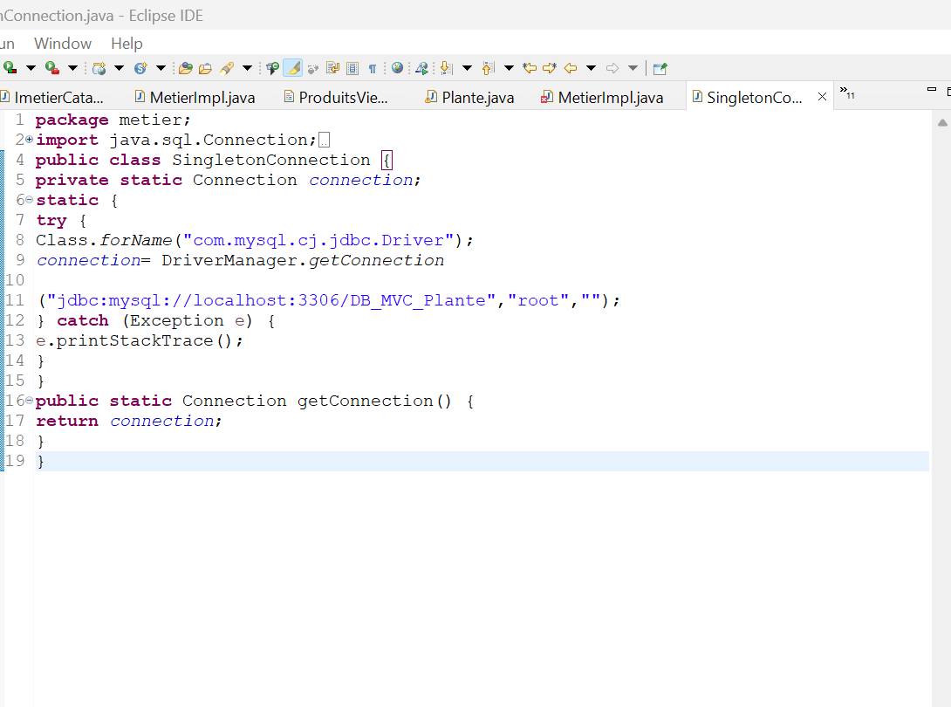

7)

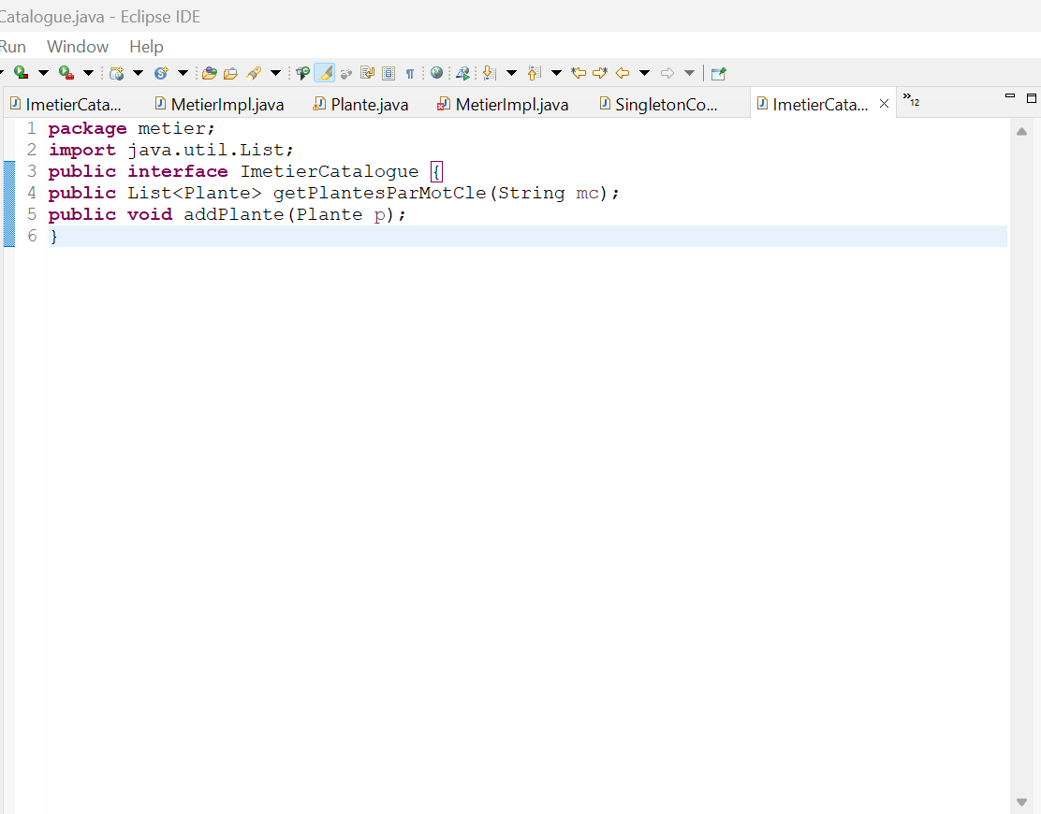

8)

9)

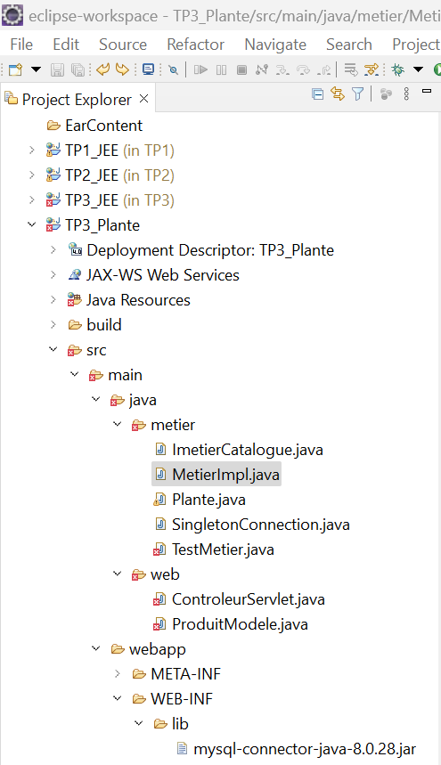

10)

11)

12)

13)

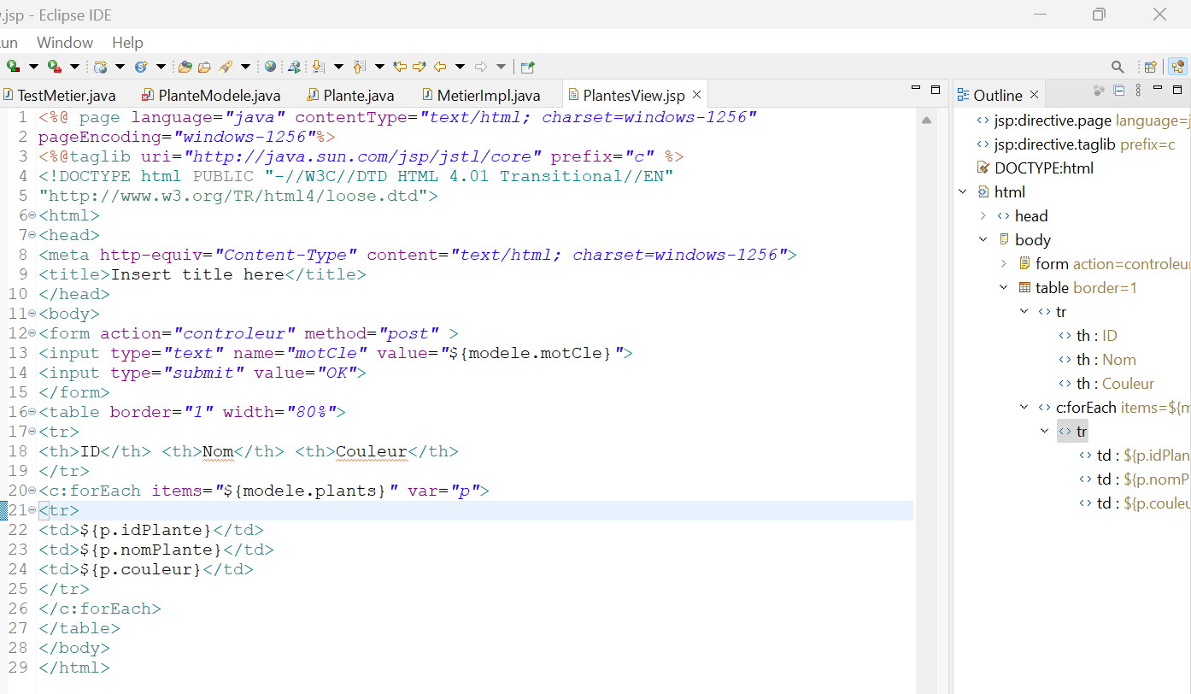

14)

15+16)

